Critical question 1.2
How are priority issues for Australia’s health identified?
Students learn about: | Students learn to:
- identifying priority health issues  - social justice principles  - priority population groups  - prevalence of condition  - potential for prevention and early intervention  - costs to the individual and community | - argue the case for why decisions are made about health priorities by considering questions such as:  - how do we identify priority issues for Australia’s health?  - what role do the principles of social justice play?  - why is it important to prioritise?

How do we identify priority issues for Australia’s health?
Identifying priority health issues is difficult as different people have different ideas as to what is most important.

- What health issues are important to you? Rank your 10 from most important to least important

In order to improve Australia’s health, governments and health authorities prioritise particular health issues, based generally on:
- how much they contribute to the burden of illness in the community
- their potential for reducing this burden.

These priority issues include:
- the health inequities experienced by certain groups within our society
- our growing and ageing population
- the high levels of chronic disease and other health problems evident in our society.

National health priority areas
The National Health Priority Areas (NHPAs) are diseases and conditions that Australian governments have chosen for focused attention because they contribute significantly to the burden of illness and injury in the Australian community.

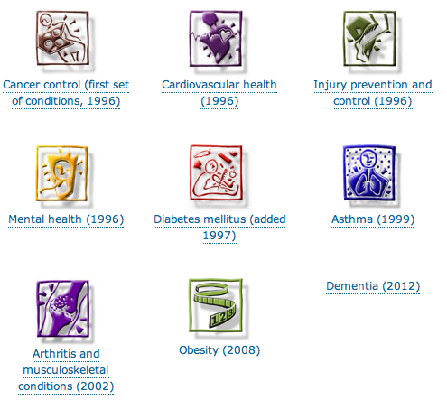

Identifying priority health issues criteria
The priority areas chosen provide a framework within which more specific goals and targets have been established. The selection of priority areas was based on five specific criteria:

Social Justice Principles
E | It is important that resources are allocated fairly so that all Australian’s have the opportunity to be healthy and have their health needs met. In some cases, this may mean allocating some resources in greater amounts to certain groups or communities in order to help redress existing health inequities
D | Australia has a diverse population with diverse needs. The population is growing and ageing, therefore health services and facilities need to increase in volume and also adapt to ensure that the specific health needs of older Australians can be met. Australia also has a significant and growing migrant population, many of whom speak English as their second language. Therefore Medicare services continue to be provided in culturally sensitive ways, such as by including translation services if needed.
S | All Australians have the right to be healthy, and the right to adequate health care that can support them in achieving optimal health. Environments need to be structured so that they are supportive of this principle. This can mean providing health care services and products at affordable cost or at no cost, ensuring that health services are located in areas and ways that can be accessed from metropolitan, rural and remote locations; and providing services and products in ways that overcome difficulties associated with disabilities and language barriers.
Outlined below are scenarios that involve social justice issues. Identify the social justice issue in each scenario and propose examples of health actions that can be taken to support social justice principles.

- A local hospital notices that women from a non-English speaking background are not taking advantage of free breast screening programs in their community. Currently, all advertising about the program is in English.

- A local high school does not have wheelchair access to the art classrooms that are upstairs. As a result, disabled students cannot participate in art classes.

- Small rural communities are experiencing significant difficulty in employing doctors and nurses. The local residents are concerned about the impact on health services.

Deﬁne ‘social justice’. What role is played by the principles of social justice?

Explain why social justice is a fundamental component of health programs.

One of the principles of social justice is that ‘all Australians should have access to a comprehensive range of health care services regardless of ﬁnancial status’:
- Identify the government policies that have been implemented to meet this principle.

- Describe how eﬀective these strategies have been.

Priority population groups
Australia is characterised by its diversity and multiculturalism. Our population has subgroups of people who have significantly different health statuses, and these inequities reflect our diverse population. The identification of priority population subgroups with inequitable health status is important for determining health priority issues. It allows health authorities to:
- determine the health disadvantages of groups within the population
- better understand the social determinants of health
- identify the prevalence of disease and injury in specific groups
- determine the needs of groups in relation to the principles of social justice.

Epidemiological information reveals that:
- indigenous populations have much higher death rates from heart disease, injury, respiratory diseases and diabetes
- people from a low socioeconomic background have a higher incidence of disease risk factors such as high blood pressure, high cholesterol levels, smoking and lower use of preventative health services
- people living in rural or isolated locations have higher death rates and a higher incidence of heart disease and injury, compared with people who reside in metropolitan areas
- men are at much greater risk than women of developing a number of diseases (including heart disease and lung cancer).

What impact do the principles of social justice have on identifying priority population groups?

Prevalence of condition
Epidemiological data provide a guiding path for determining the priority areas for Australia’s health. Epidemiology provides information on the incidence of mortality and morbidity in the Australian population and thus, to a certain degree, on the health status of the population. It reveals the prevalence of disease and illness, and helps us to identify risk factors. The identification of risk factors can indicate the potential for change in a health area. High prevalence rates of a disease indicate the health and economic burden that the disease or condition places on the community. Statistics reveal, for example, that cardiovascular disease is the leading cause of preventable death in Australia.

Discuss the reasons for the importance of prioritising. Does this mean other health issues might be neglected? What if the prevalence of another health condition increases?

Potential for prevention and early intervention
- Priority health issues are identified when a disease is preventable or has the potential for intervention
- Most of Australia’s major causes of illness and death are due to modifiable lifestyle behaviours. These are known as Lifestyle diseases.
- For health problems that are not lifestyle-related the potential for change is extremely limited and progress is more reliant on research and medical advances
- Education and awareness of risk factors can lead to behaviour change and a reduction in incidence. Such risk factors include smoking, sun exposure and drink driving.
- Environmental modiﬁcations can also contribute to a reduction in incidence; for example, shaded areas to reduce skin cancer, dual-lane highways to reduce road injury, and lean beef and low-fat milk to reduce heart disease.
- To simply blame individuals for their behaviour ignores the social determinants
Explain why the ‘potential for prevention and early prevention’ was a criterion in the identiﬁcation of priority issues

Costs to the individual and community
Disease and illness can place a great economic and health burden on the individual, which can be measured in terms of financial loss, loss of productivity, diminished quality of life and emotional stress. The cost of treatment, medication and rehabilitation may be more than the individual can afford. Further, injury and disease may affect the individual’s ability to be productive, and often the need to stop work during treatment and rehabilitation reduces the individual’s ability to earn and thus to maintain their quality of life. The emotional stress and social upheaval that often result from illness and injury are another burden. It is difficult to estimate the pain and suffering that an individual experiences as a result of illness and injury, but it is a significant factor. In addition, illness, disease and premature death all place an economic burden on the community.

The impact of disease in economic terms can provide some estimate of the cost to the community. This cost can be useful for health authorities when they are prioritising health issues and determining health interventions.

Illness results in both direct and indirect costs.

Direct costs include the money spent on diagnosing, treating and caring for the sick, plus the money spent on prevention. These costs can be estimated from the expenses of medical services, hospital admissions, pharmaceutical prescriptions, prevention initiatives, research, screening and education, for example.

Indirect costs are the value of the output lost when people become too ill to work or die prematurely (for example, the cost of forgone earnings, absenteeism and the retraining of replacement workers).

Australia’s expenditure on health
These include:
- an ageing population - there is still concern that having an older population might place an extra burden on Australia’s health costs.

- a more informed population - Health promotion and illness-prevention messages have resulted in a population more informed about ill-health. This might result, in turn, in an increase in the use of health services, especially in relation to prevention. In the longer term, spending money on prevention and early detection of illness might decrease overall health costs. In the short term, however, having a more informed and health conscious population does tend to cause people to use more medical services than previously, and this puts immediate pressure on the health care budget.

- increased use of Medicare - The ease and simplicity that Medicare has brought to health care has resulted in a steady increase in the use of doctors’ services, especially in urban areas where there are many doctors. As noted above, this might result in longer-term benefits if conditions are detected earlier and prevented from developing into more serious (and expensive) problems. It places a burden on the health budget now, however, and in the immediate future. Even if there might be longer-term benefits, these are difficult to measure, and the immediate concern is that health costs are going up because of the increased number of consultations.
There is also concern that the ease and simplicity of Medicare might lead to some people seeing doctors for trivial matters

- advances in medical technology - Improved technology has resulted in a wider range of treatments available. Many of these treatments utilise the latest expensive technology; for example, organ transplants, use of lasers, joint replacements, open-heart surgery. People obviously want the best possible treatment, but costs are increasing as a result.

HSC QUESTIONS 2010
- Which of the following results of illness have indirect costs to the community?
- Absenteeism, education and screening, loss of potential earnings
- Absenteeism, loss of potential earnings, retraining in the workplace
- Loss of potential earnings, pharmaceutical prescriptions, absenteeism
- Loss of potential earnings, retraining in the workplace, pharmaceutical prescriptions
- An increase in the life expectancy of Australians is most likely to result from
- Lower morbidity rates.
- Higher morbidity rates.
- Lower infant mortality rates.
- Higher infant mortality rates.

- The criteria used to determine Australia’s priority health issues are
  - Social justice principles, potential for prevention and morbidity rates.
  - Priority population groups, life expectancy and social justice principles.
  - Cost to individual and communities, mortality rates and social justice principles.
  - Social justice principles, priority population groups and prevalence of condition.
- Which option best explains the decrease in mortality rates in Australia over the last century?
 | Improved | Decreased | Access to
 | Medical technology | Infectious disease | Vaccination programs
 | Medical technology | Infectious disease | Private health insurance
 | Knowledge on Infectious disease | Chronic disease | Medicare
 | Life expectancy | Chronic disease | Medicare

HSC 2011
- What is the current leading cause of death for both males and females in Australia?
- Cerebrovascular disease
- Coronary heart disease
- Lung cancer
- Diabetes

- Four health conditions identified as W, X, Y and Z are shown in the following graph.
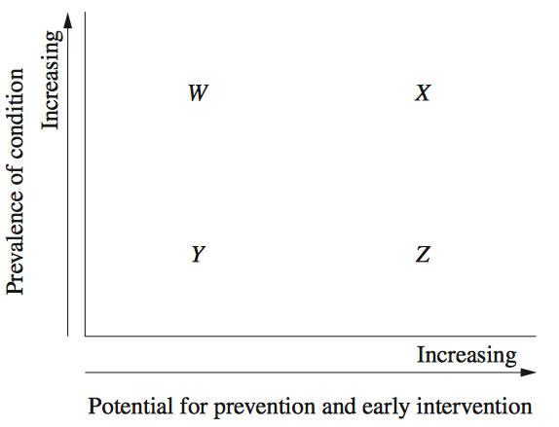

Which of these conditions is most likely to be identified as a health priority issue?
(A) W
(B) X
(C) Y
(D) Z

HSC 2012

- Which condition is currently the leading cause of mortality in Australia?
  - Asthma
  - Lung cancer
  - Breast cancer
  - Cardiovascular disease
- Which of the following diseases is now three times more prevalent than it was 20 years ago in Australia?
- Bronchitis
- Diabetes
- Influenza
- Polio

How is epidemiology used to improve the health of Australians? Provide examples. (6)

Justify why cardiovascular disease has been identiﬁed as a health priority issue in Australia (10) (2006)

